Safaan Hashmi

Lecture 4 04-Aug-2024

Practice Problems

**1. Write a program to demonstrate nested if-else statement**

import java.util.*;

class HelloWorld {

public static void main(String[] args) {

Scanner sc = new Scanner(System.in);

System.out.println("Enter Age");

int age = sc.nextInt();

System.out.println("Enter Gender (M/F)");

String gender =sc.next();

if(gender.equals("M"))

{

if(age<18){

System.out.println("Hello Sir, you are not elegible to create account");

}

else{

System.out.println("Hello Sir, you are elegible to create account");

}

}

else{

if(age<18){

System.out.println("Hello Ma'am, you are not elegible to create account");

}

else{

System.out.println("Hello Ma'am, you are elegible to create account");

}

}

}

}

OUTPUT -:

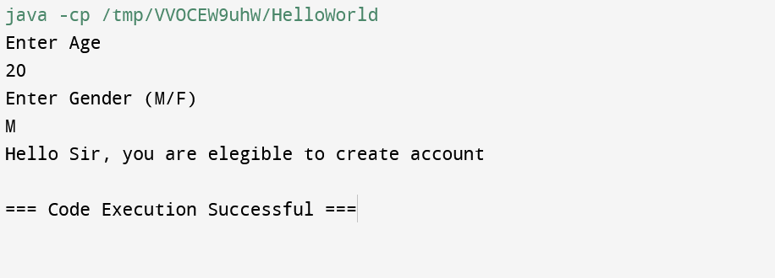

**2. Write a program to demonstrate the use of for loop in java.**

class LoopsInJava {

public static void main(String[] args) {

System.out.println("For loop");

int n = 5;

for (int i = 1; i <= n; ++i) {

System.out.println("Java is fun");

}

}

}

OUTPUT -:

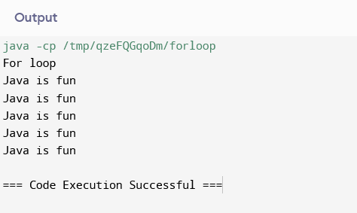

**3. Write a program to demonstrate the use of the Switch Case Statement.**

class SwitchCase {

public static void main(String[] args) {

int number = 44;

String size;

switch (number) {

case 29:

size = "Small";

break;

case 42:

size = "Medium";

break;

case 44:

size = "Large";

break;

case 48:

size = "Extra Large";

break;

default:

size = "Unknown";

break;

}

System.out.println("Size: " + size);

}

}

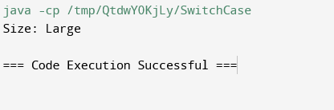

**4. Write a program to demonstrate the use of for each loop.**

class ForEach {

public static void main(String[] args) {

System.out.println("For-Each Loop");

int[] numbers = {10, 20, 30, 40};

for (int number: numbers) {

System.out.println(number);

}

}

}

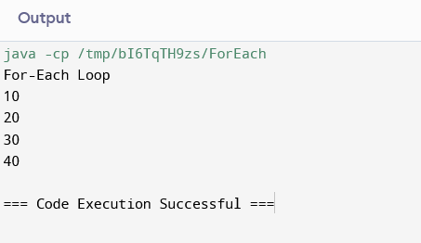

**5. Write a program to demonstrate the use of while and do..while loop.**

class While {

public static void main(String[] args) {

System.out.println("While loop");

int i=1;

while(i<=5){

System.out.println(i);

i++;

}

System.out.println("Do-While loop");

int j=1;

do{

System.out.println(j);

j++;

}while(j<=10);

}

}

